Gisella Adair
Assignment 1_2
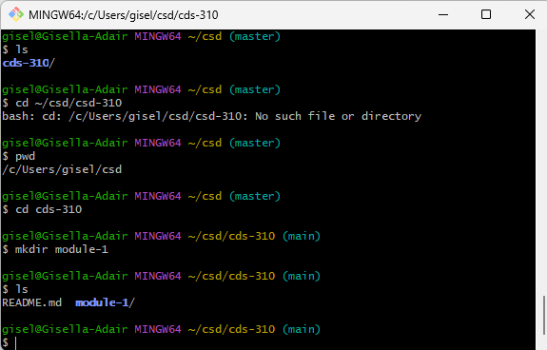git

